QUANTUM WOLF

DATA INTELLIGENCE & RESEARCH LAB

**DATE:08-03-2025 TO 09-03-2025**

**NAME:ABDUL ZUHAIL M**

**Real-Time Brain-Computer Interface Signal Decoding Report**

**Problem Statement**

Brain-Computer Interfaces (BCIs) often face challenges due to the low signal-to-noise ratios (SNR) in non-invasive EEG data, which can lead to delays and inaccuracies in real-time applications, such as controlling prosthetic devices or other assistive technologies.

**Introduction**

This report outlines a streamlined approach to decoding brain signals in real time, focusing on classifying motor intentions (e.g., left, right, none) from EEG signals. The goal is to improve the efficiency and accuracy of BCIs for practical applications.

**Workflow Overview**

The following steps were followed to build the brain-computer interface signal decoding model:

**1.Load EEG Data**

**Widgets Used:**

* File → Load synthetic_eeg_data.csv
* Data Table → View EEG signals

**Steps:**

* The EEG dataset was loaded and inspected using the Data Table widget to ensure data integrity and familiarize with the structure.

**Output:**

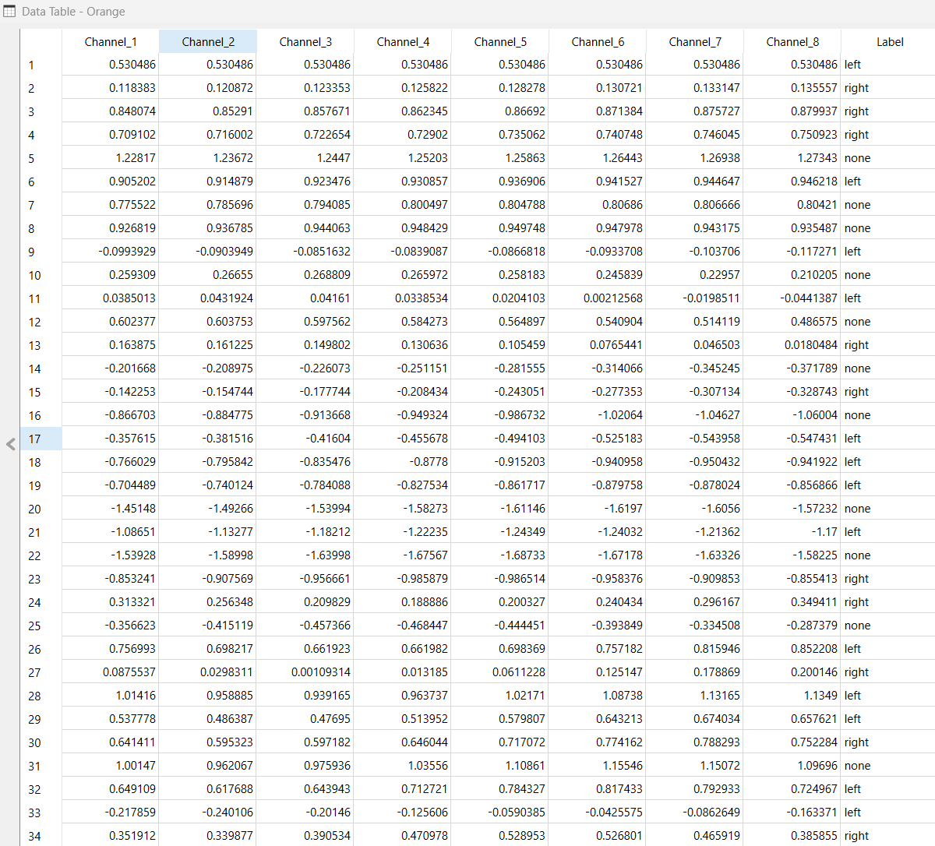

**2.Feature Selection**

**Widgets Used:**

* Select Columns → Choose EEG channels as input & Label as target
* Distributions → Analyze feature distributions

**Steps:**

* Unnecessary columns were removed to retain only the relevant EEG features and target labels, simplifying the dataset for further processing.
* The Distributions widget was used to analyze the distribution of EEG signal features, helping to understand data variability and identify potential outliers.

**Output:**

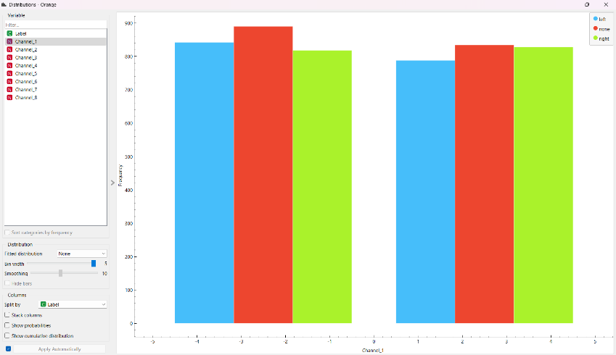

3.**Feature Extraction Using PCA**

**Widgets Used:**

* PCA (Principal Component Analysis) → Extracts essential EEG patterns
* Scatter Plot → Visualizes feature relationships

**Steps:**

* PCA was applied to reduce the dimensionality of the data, extracting the most significant EEG patterns while minimizing noise.
* The Scatter Plot widget was used to visualize the relationships between the principal components, aiding in pattern recognition and feature analysis.

**Output:**

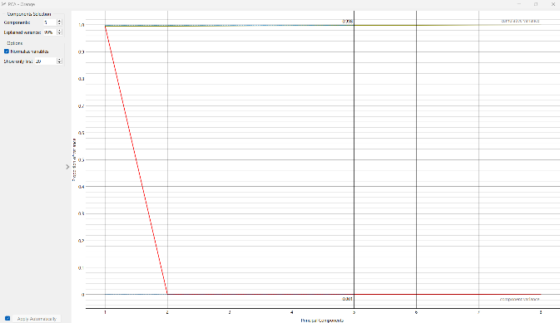 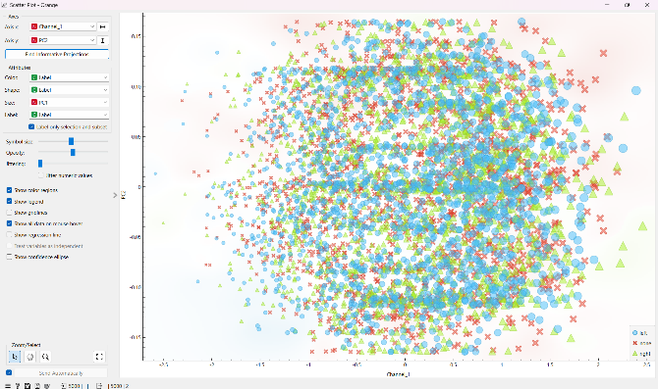

**4.EEG Pattern Clustering with Self-Organizing Maps (SOMs)**

**Widgets Used:**

* Self-Organizing Map (SOM) → Identifies motor intent patterns

**Steps:**

* SOM was employed to detect and cluster patterns associated with different motor intentions, providing a clearer understanding of the underlying EEG signal structures.

**Output:**

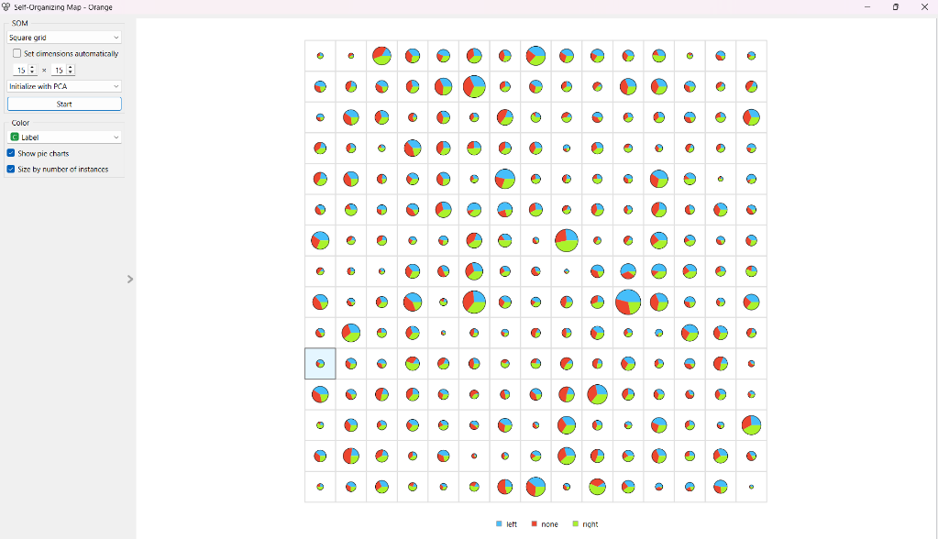

**5.Train Classifier (Gradient Boosting)**

**Widgets Used:**

* Gradient Boosting → Advanced classifier
* Test & Score → Evaluates model performance

**Steps:**

* A Gradient Boosting classifier was trained to predict motor intentions from the processed EEG data.
* The model's performance was evaluated using cross-validation to ensure robustness and accuracy.

**6.Analyze Predictions**

**Widgets Used:**

* + Box Plot → Visualizes classification results
  + Confusion Matrix → Evaluates model accuracy

**Steps:**

* + The Box Plot was used to display the distribution of predictions, providing insights into the model's performance across different classes.
  + The Confusion Matrix was employed to assess the classification accuracy, highlighting areas where the model excelled or needed improvement.

**Output:**

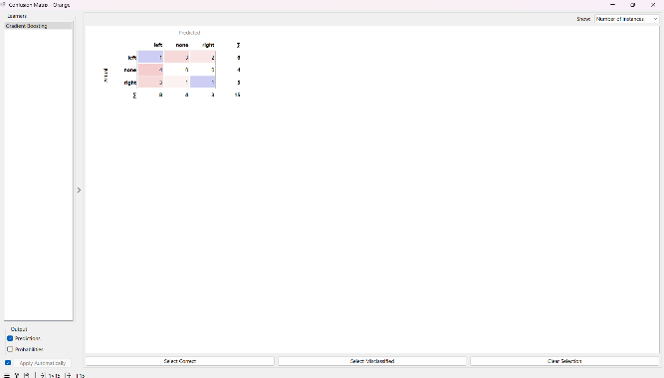 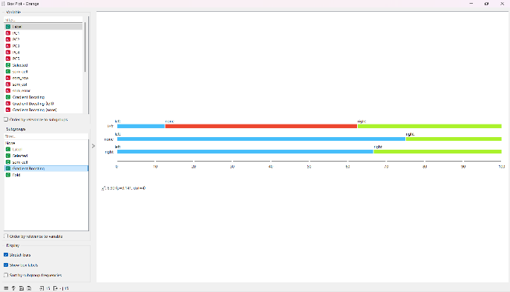

**Workflow of Orange:**

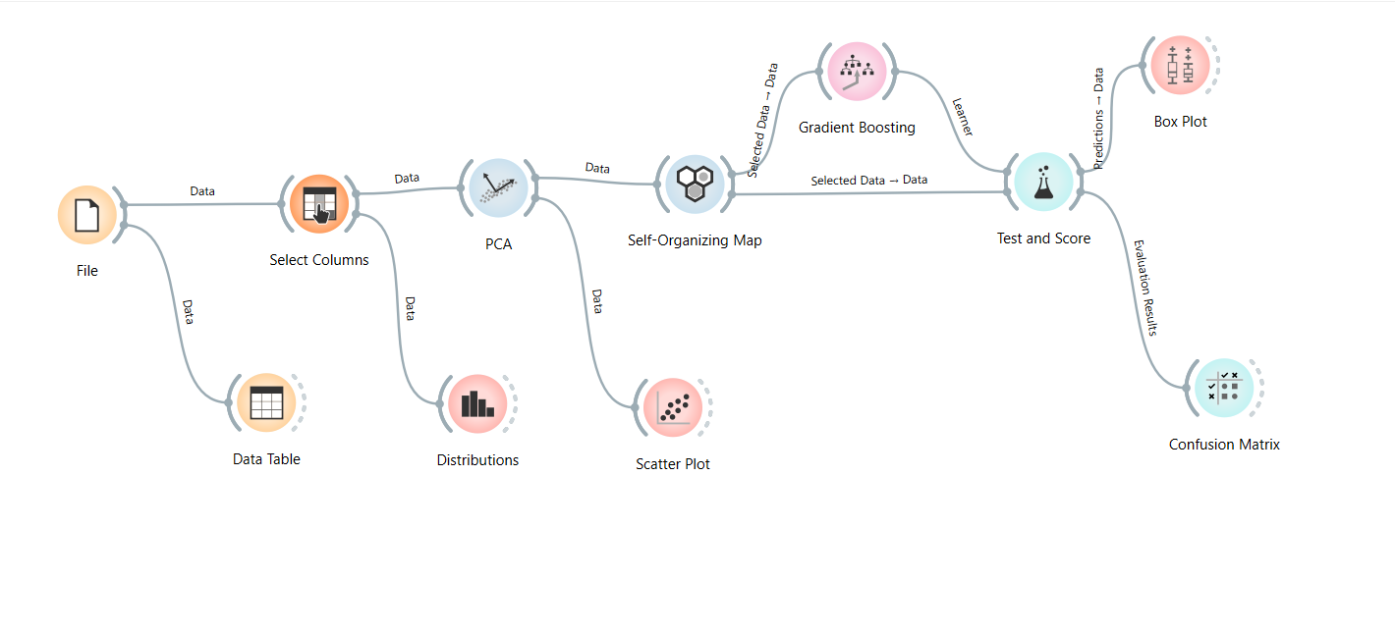

**Challenge Faced: Handling EEG Data Format**

**Problem:**

The original EEG dataset was in .gdf format, which is complex and not directly supported by Orange, creating a bottleneck in data loading and processing.

**Solution:**

A synthetic EEG dataset was generated in .csv format, ensuring compatibility with Orange while maintaining realistic EEG signal properties. This allowed for smooth data loading, feature extraction, and analysis, enabling the project to proceed efficiently. However, the synthetic data may lack some real-world variability, which could be addressed in future work by validating the model on real-world EEG data.

**Conclusion**

The workflow demonstrated an efficient and effective approach for decoding brain signals in real time. By leveraging machine learning techniques such as PCA, SOM, and Gradient Boosting, the model achieved accurate classification of motor intentions. This approach enhances the practicality of BCIs, making them more reliable for real-world applications like prosthetic control and other assistive technologies. Future work could explore further optimization of the model and integration with real-time systems for immediate feedback and control.